**New Course Exam questions by topic**

Please remember to photocopy 4 pages onto one sheet by going A3→A4 and using back to back on the photocopier

**These questions are taken from the Sample Papers (higher level and ordinary level) and the 2023 exam papers (higher level and ordinary level) plus Deferred 2023 (higher level only).**

Almost all topics are represented here somewhere so it offers a very comprehensive overview of the new course. Not everything has been asked however and it will take a few more years before we get to that point (for example there are aspects of differential equations which have yet to be asked and there are 4 specific examples of project scheduling that haven’t appeared to date either). For a comprehensive overview of the course you should purchase one or both of the following textbooks:

***Applied Mathematics: A Comprehensive Course for Leaving Certificate*** by Dominick Donnelly [www.appliedmathematics.ie](http://www.appliedmathematics.ie)  
***Fundamental Applied Maths*** by Oliver Murphy [www.folens.ie](http://www.folens.ie)

Fully worked solutions from Dominick Donnelly here[*appliedmathematics.ie/index.php/students/exam-solutions*](https://appliedmathematics.ie/index.php/students/exam-solutions)

Fully worked solutions (plus lots more) from Joe Kennedy here*:* [*https://www.jkmaths.net/exam-paper-solutions*](https://www.jkmaths.net/exam-paper-solutions)

Screencasts of worked solutions to HL 2023 and Sample Paper (plus lots more) from Shane Molloy here: <https://www.molloymaths.com/applied-maths>

Exam Papers (in pdf and Word format) plus Marking Schemes (and lots more) from: [**thephysicsteacher.ie/exammaterialappliedmaths.html**](http://www.thephysicsteacher.ie/exammaterialappliedmaths.html)

A good idea is to look at as many sources as you can for solutions as there is often more than one approach and some can be much easier to understand and/or remember than others.

[Screencasts of worked solutions to various older past paper question plus comprehensive resources for all topics](https://docs.google.com/document/d/1PEdLGfzV7Z3JErHQsVvKGudT_gAiqvGpz6ZKCrL1vKw/edit?usp=sharing)

You can find this document plus all other Applied Maths booklets on the homepage of thephysicsteacher.ie

Last updated: 10/02/2024

Noel Cunningham

Contents

Dimensional analysis 3

Vectors and the dot product 4

Linear acceleration 6

Projectiles 10

Pulleys and Wedges 14

Collisions 17

Work done on a stretched string 20

Circular motion 21

Horizontal circular motion 21

Vertical circular motion 24

Difference Equations 25

First Order Difference Equations – Ordinary level 25

First Order Difference Equations – Higher level 28

Second Order Homogeneous Difference Equations – Ordinary level 30

Second Order Homogeneous Difference Equations – Higher level 31

Second Order Inhomogeneous Difference Equations – Higher level 32

Differential equations 34

Integration and differentiation 38

Difference equations and differential equations 39

Networks and Graphs 40

Matrices and Adjacency matrices Ordinary Level 40

Matrices and Adjacency matrices Higher Level 41

Minimum spanning trees: Kruskals and Prims algorithms Ordinary Level 42

Minimum spanning trees: Kruskals and Prims algorithms Higher Level 44

Optimal Paths & Project Scheduling 46

Dijkstra’s algorithm Ordinary Level 46

Dijkstra’s algorithm Higher Level 47

Early & Late times & Critical Paths: Ordinary Level 49

Precedence tables PLUS Early & Late times & Critical Paths: Higher Level 51

Precedence tables PLUS Early & Late times & Critical Paths PLUS Gantt charts: Higher Level 55

Bellman’s Principle of Optimality 57

# Dimensional analysis

**2023 OL Question 5 (b)**

The algebraic formulae below are written in terms of momentum 𝑝, mass 𝑚, displacement 𝑠 and time 𝑡.

Which of the formulae, **X** or **Y**, has the same units as the units for velocity, m s–1?

Use dimensional analysis (comparison of units) to justify your answer.

X: $\sqrt{\frac{2pm}{st}}$ Y: $\sqrt{\frac{2ps}{mt}}$

**2023 HL Question 3**

Use dimensional analysis to show that the units for the expression $\sqrt{\frac{g \tan{α}}{3.5+4.3 \sin{α}}}$ are equivalent to the units for 𝜔.

**Sample Paper HL Question 6**

Use dimensional analysis to show that the units for the expression you derived in part (*v*) are equivalent to the units for velocity.

The expression in part (*v*) (obviously not listed on the exam paper) is: m s-1

**2023 HL Deferred Question 1 (b)**

Use dimensional analysis to show that the units for the expression you derived in part **(***iii***)** are equivalent to the units for period.

The expression derived in part (*iii*) (obviously not listed on the exam paper) is: $T=2π\sqrt{\frac{l\cos{θ}}{g}}$

# Vectors and the dot product

**Sample paper Ordinary Level Question 1 (a)**

A displacement vector, $\vec{b}$, has a magnitude of 15 km and a direction 𝛼 north of east, where $\tan{α=\frac{4}{3}}$

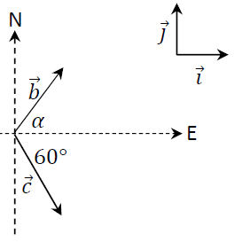

A second displacement vector, $\vec{c}$, has a magnitude of 10√3 km and a direction 60° south of east, as shown in the diagram.

1. Express $\vec{b}$ and $\vec{c}$ in terms of the unit vectors $\vec{i}$ and $\vec{j}$.
2. Calculate $\vec{b}$ ⋅ $\vec{c}$, the dot product of $\vec{b}$ and $\vec{c}$.

A third displacement vector, $\vec{d}$, is perpendicular to $\vec{b}$.

$\vec{d}\vec{i}$ = $-4\vec{i}$ + $k\vec{j}$.

1. Calculate 𝑘.

**2023 OL Question 3**

Two vectors 𝑞⃗ = 6𝚤⃗ + 8𝚥⃗ and 𝑟⃗ = - 4𝚤⃗ + 3𝚥⃗ are shown on the diagram below.

𝑞⃗ makes an angle 𝛼 with the positive direction of the 𝚤⃗ axis and 𝑟⃗ makes an angle 𝛽 with the negative direction of the 𝚤⃗ axis.

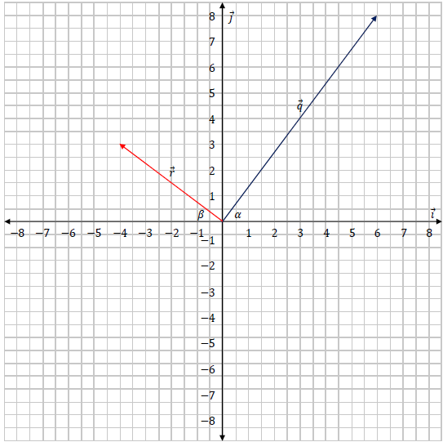

1. Calculate 𝑠⃗, where 𝑠⃗ = - ½ 𝑞⃗ - 𝑟⃗.
2. Draw 𝑠⃗ on the axes shown.
3. Calculate |𝑞⃗| and |𝑟⃗|.
4. Calculate 𝛼 and 𝛽.
5. Calculate 𝑞⃗. 𝑟⃗, the dot product of 𝑞⃗ and 𝑟⃗.
6. Calculate the angle between 𝑞⃗ and 𝑟⃗.
7. Calculate the value of 𝑘 and 𝑡 such that 𝑘𝑞⃗ + 𝑡𝑟⃗ = -10𝚤⃗ + 20𝚥⃗.

# Linear acceleration

**Sample paper Ordinary Level Question 8**

Pole 𝑃 and traffic lights 𝐿 lie 800 m apart on a straight level road, as in the diagram below.

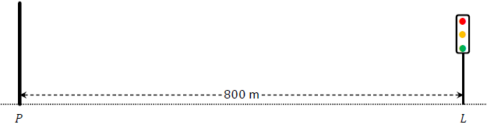

A car passes 𝑃 travelling towards 𝐿 with a speed of 5 m s–1 and an acceleration of 0.4 m s–2.

At the same moment, a motorcycle passes 𝐿 travelling towards 𝑃 with a speed of 4 m s–1 and an acceleration of 0.6 m s–2.

1. Calculate the speed of the car 15 s after it passes 𝑃.
2. 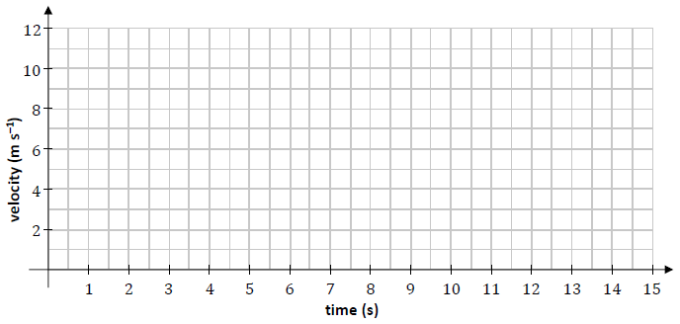Draw a velocity‐time graph for the motion of the car for the first 15 s after it passes 𝑃.

1. Write an expression for 𝑠*c*(𝑡), the displacement of the car from 𝑃 at any time 𝑡.
2. Write an expression for 𝑠*m*(𝑡), the displacement of the motorcycle from 𝐿 at any time 𝑡.
3. The car and the motorcycle pass each other after 𝑇 seconds. Calculate 𝑇.
4. At the instant that the car and motorcycle pass each other, the car stops accelerating and continues travelling at the velocity it has at that instant.

Calculate the total time it takes the car to travel from 𝑃 to 𝐿.

**2023 OL Question 6**

A car is parked at a point 𝑃. At time 𝑡 = 0 s the car begins to travel in a straight line with a constant acceleration of 4.5 m s–2. When the car has reached a velocity of 18 m s–1 it stops accelerating. The car continues travelling at a velocity of 18 m s–1 until 𝑡 = 30 s.

1. Calculate the time it takes for the car to reach 18 m s–1.
2. Calculate the distance travelled by the car while it is accelerating.
3. Calculate the distance travelled by the car when 𝑡 = 30 s.

At 𝑡 = 0 a cyclist passed the car while travelling with a velocity of 8.5 m s–1 and an acceleration of 0.5 m s–2. The cyclist accelerated until he reached a velocity of 11 m s–1, which he then maintained.

1. Calculate the time taken for the cyclist to reach a velocity of 11 m s–1.
2. Using the axes below, draw an accurate velocity‐time graph showing the motion of the car and the motion of the cyclist for the first 30 s of their motion.
3. Calculate the distance between the car and the cyclist when 𝑡 = 20 s.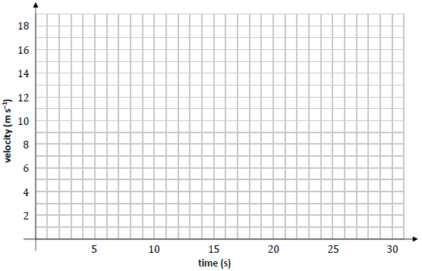

**Sample Paper HL Question 3 (b)**

Two athletes, Brian and Clara, are taking part in a relay race. Brian is preparing to hand over the baton to Clara. During the hand‐over of the baton the athletes need to be running in the same straight line and at the same velocity.

As Brian approaches Clara’s position at a constant speed of 11 m s–1, Clara starts running from rest with constant acceleration 𝑓.

A short time later Brian begins to decelerate at 2 m s–2.

Clara receives the baton 2.5 s after she starts running.

The baton is exchanged when Clara is 75 cm ahead of Brian and when both athletes have a speed of 8 m s–1.

After the baton is exchanged, Brian continues to decelerate at 2 m s–2 until he comes to rest.

Clara continues to accelerate at 𝑓 until she reaches her maximum speed of 12 m s–1, which she then maintains.

1. Calculate the time it takes for Brian to decelerate before he exchanges the baton.
2. Using the axes below, draw an accurate velocity‐time graph for the motion of each runner.   
   Time is measured from the instant that Clara begins to run.   
     
   Relevant calculations should be shown in the space below.

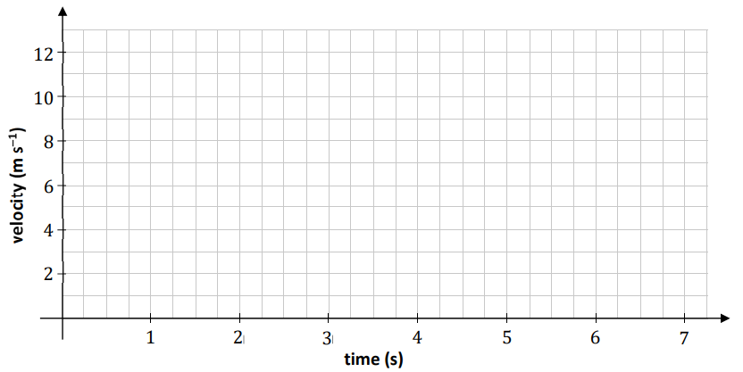

1. Calculate the distance between the two athletes when Clara begins to run.

**2023 HL Question 5 (b)**

Áine travels by car from her house to work each morning.

On Monday morning she starts her car and accelerates uniformly for 40 s to a speed of 22.5 m s–1.

Áine then travels at this speed for 8 minutes until decelerating uniformly to rest at her work.   
She reaches her work at exactly 08: 30.

On Tuesday morning Áine leaves her house 140 s later than the day before.

She takes the same route to work.  
She starts her car and accelerates at 1.5 m s–2 for 20 s, then maintains this steady speed for 6 minutes before decelerating uniformly to rest at her work.

She again reaches her work at exactly 08: 30.

Calculate the time when Áine leaves her house on Tuesday morning.

**2023 HL Deferred Question 6 (a)**

Motorbike 𝐵 travelling with speed 5.5 m s–1 and constant acceleration 0.5 m s–2 on a straight stretch of road is overtaken, at a road sign 𝑆, by car 𝐶 travelling with speed 11 m s–1 and constant acceleration 0.125 m s–2.

1. Calculate the greatest distance that car 𝐶 is ahead of motorbike 𝐵.
2. Calculate the distance from 𝑆 to the point where 𝐵 overtakes 𝐶.
3. Using the axes below, sketch the shape of the displacement‐time graph for the displacement of 𝐵 relative to 𝑆 for the first 30 s of its motion after it passes 𝑆.

Using the same axes, sketch the shape of the displacement‐time graph for the displacement of 𝐶 relative to 𝑆 for the same period of time.

Include scales on your axes.

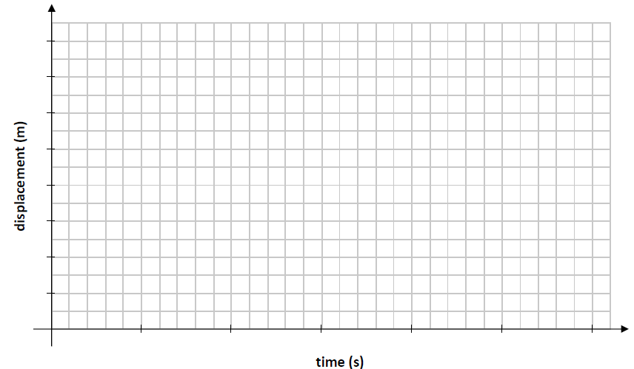

# Projectiles

**Sample paper Ordinary Level Question 4**

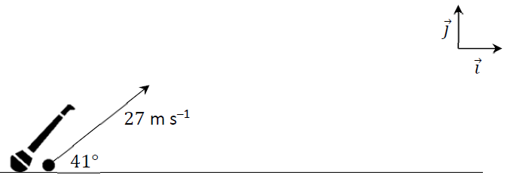A camogie player strikes a sliotar off the horizontal ground. It travels with an initial velocity of 27 m –1 at an angle of 41° to the ground, as shown in the diagram.

1. Express the initial velocity of the sliotar in terms of the unit vectors $\vec{i}$ and $\vec{j}$.  
     
   The motion of the sliotar may be modelled as projectile motion in a vertical plane, ignoring the effects of wind and the effects of air resistance.
2. Calculate the speed and direction of the sliotar 0.5 s after it is struck.
3. Calculate the time it takes for the sliotar to reach its maximum height.
4. Calculate the maximum height of the sliotar.
5. The crossbar in a camogie goal is 2.5 m above the ground. Calculate the time interval during which the sliotar is at least 2.5 m above the ground.
6. The graph below shows the predicted path of the sliotar when the effects of wind and the effects of air resistance are ignored. The graph is not drawn to scale.
7. Using the same axes, sketch the path you would expect the sliotar to take if the model took into account the effects of air resistance (but not the effects of wind).

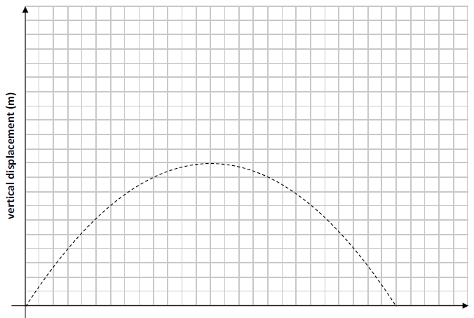

**2023 OL Question 5 (a)**

A particle is projected through the air with a velocity of 14𝚤⃗ + 24.5𝚥⃗ m s–1 from horizontal ground. The effects of air resistance and wind may be ignored.

1. Calculate the time of flight of the particle.
2. Calculate the maximum range of the particle.
3. Calculate the times when the particle is at a height of 20 m, above the ground.
4. The graph below represents the predicted path of this particle when the effects of wind and air resistance are ignored. The graph is not drawn to scale.
5. 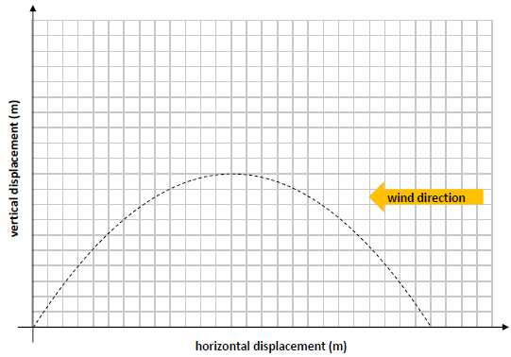Using the same axes, sketch the path you would expect the particle to take if the model took into account the effects of wind blowing from the east (but not the effects of air resistance).

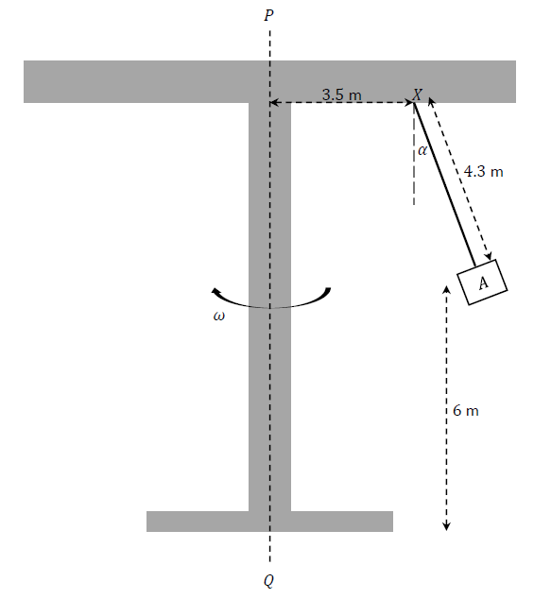**2023 HL Question 3**

The person sitting in seat 𝐴 throws a small orange into the air.

The person imparts an upward vertical velocity component of 4 m s–1 to the orange.

Calculate the time from when the orange is thrown until it hits the ground

**Sample Paper HL Question 4 (a)**

A ball is projected from a point on horizontal ground, with initial speed 𝑢 and at an angle 𝛼

to the horizontal. The ball reaches a maximum height of 𝐻0 above the horizontal.

Upon landing, the ball bounces with a maximum height of 𝐻1.

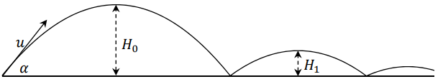

The coefficient of restitution between the ball and the ground is 𝑒.

1. Calculate $\frac{H_{0}}{H_{1}}$.
2. The ball continues bouncing. Find an expression (in terms of 𝑒 and 𝐻0) for 𝐻5, the maximum height of the ball after it lands on the ground for the fifth time.

**2023 HL Question 8**

Two balls, 𝑃 and 𝑄, are projected into the air from points 𝐴 and 𝐵, which are a distance 𝐷 apart along the horizontal 𝚤⃗ axis. The motion of the balls may be modelled as projectile motion in a vertical plane, ignoring the effects of air resistance.

𝑃 is projected from point 𝐴 at time 𝑡 = 0 s with initial velocity 38 m s–1 at 41° to 𝐴𝐵.

𝑄 is projected from point 𝐵 at time 𝑡 = 1 s with initial velocity 𝑢 m s–1 at 64° to 𝐵𝐴.  
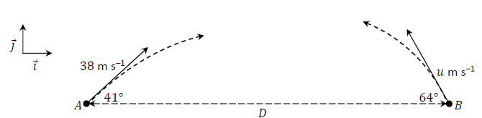

𝑃 and 𝑄 collide in mid‐air when 𝑡 = 3 s.

1. Show that 𝑢 = 28 m s–1 to the nearest whole number.
2. Calculate 𝐷.
3. In terms of 𝚤⃗ and 𝚥⃗, calculate $\vec{v_{P}}$, the velocity of 𝑃, and $\vec{v_{Q}}$, the velocity of 𝑄, when the balls collide, i.e. when 𝑡 = 3 s.
4. Calculate the dot product of $\vec{v_{P}}$ and $\vec{v_{Q}}$ when 𝑡 = 3 s.
5. Hence or otherwise calculate the acute angle between $\vec{v_{P}}$ and $\vec{v_{Q}}$ when 𝑡 = 3 s.

# Pulleys and Wedges

**Sample paper Ordinary Level Question 6**

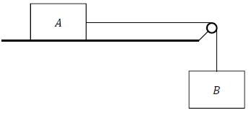Block 𝐴, of mass 4 kg, rests on a rough horizontal table. It is connected to block 𝐵, of mass 6 kg, by a light inextensible string which passes over a fixed smooth pulley at the edge of the table.

When the system is released from rest, block 𝐴 is 40 cm from the pulley.

The coefficient of friction between block 𝐴 and the table is ½.

1. Draw diagrams to show the forces acting on blocks 𝐴 and 𝐵 while they are moving.
2. Calculate the frictional force acting on block 𝐴 while it is moving.
3. Calculate the tension in the string and the acceleration of the blocks while they are moving.
4. Calculate the speed of block 𝐴 when it reaches the pulley.
5. Explain why it would not be appropriate to model this problem using the principle of conservation of energy.

**2023 OL Question 9 (a)**

A student models the motion of a car that is being driven on a rough straight horizontal road on a dry day in June. The car has a mass of 1200 kg. The student carries out some research and estimates that the coefficient of friction, 𝜇, between the car and the dry road is ¼.

The student also finds out that this car has a driving force (tractive force) of 6500 N.

The student models the motion of the car starting from rest.

1. Calculate the force of friction that acts on the car while it is moving.
2. Calculate the acceleration of the car.
3. If the student modelled the motion of this car being driven on the same road in December, explain one refinement that the student might make to the mathematical model.

**2023 OL 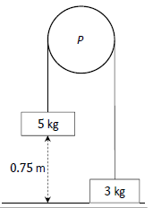Question 9 (b)**  
A fixed smooth pulley, 𝑃, has blocks of masses 5 kg and 3 kg hanging freely from either side. The blocks are connected by a light inextensible string which passes over the pulley 𝑃.

The 3 kg block is initially at rest on a smooth table and the 5 kg block is held at a distance of 0.75 m above the table, as shown in the diagram.

The system is then released from rest.

1. Draw separate diagrams to show the forces acting on the blocks while they are moving.
2. Calculate the acceleration of the system.
3. Calculate the kinetic energy of the 5 kg block as it hits the table.

**2023 HL Question 5 (a)**

Block 𝑃 (of mass 6.3 kg) and block 𝑄 (of mass 2.5 kg) are held at rest on a rough surface.

They are connected by a light inextensible string which passes over a smooth fixed pulley.

Block 𝑄 lies on the horizontal part of the surface and block 𝑃 lies on the part of the surface that is inclined at 25° to the horizontal, as shown in the diagram.

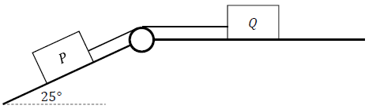

The coefficient of friction between each block and the surface is 0.2.

The blocks begin to move when they are released.

1. Show, on separate diagrams, the forces acting on the blocks while they are moving.
2. Calculate the acceleration of the blocks.

**Sample Paper HL Question 7 (b)**

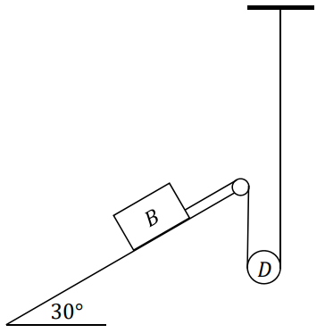A small smooth moveable disk 𝐷, of mass 0.2 kg, rests on a light inextensible string. One end of the string is connected to block 𝐵, of mass 4 kg, which rests on a rough plane inclined at 30° to the horizontal.

The other end of the string is connected vertically to a fixed point.

The coefficient of friction between block 𝐵 and the inclined plane is $\frac{1}{10}$.

When the system is released from rest, 𝐷 moves upwards with acceleration 𝑎.

The tension in the string is 𝑇.

1. Show, on separate diagrams, the forces acting on block 𝐵 and disk 𝐷 while they are moving.
2. Explain why the acceleration of 𝐵 is 2𝑎.
3. Calculate 𝑎 and 𝑇.

**2023 HL Deferred Question 8**

Two rectangular blocks 𝐴 and 𝐵, of mass 5 kg and 10 kg, rest on two sides of fixed triangular wedge 𝑋𝑌𝑍, with side 𝑌𝑍 lying on the horizontal ground, as shown in the diagram. The blocks are connected by a light inextensible string passing over a smooth pulley at 𝑋.

The edge of block 𝐵 is a distance of 0.4 m from the ground along side 𝑋𝑍. The angles of inclination of sides 𝑌𝑋 and 𝑍𝑋 with the horizontal ground are 40° and 55° respectively.

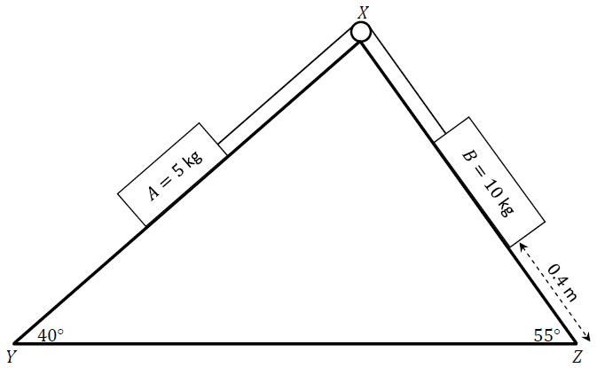

𝜇1, the coefficient of friction between side 𝑌𝑋 and block 𝐴, is .

𝜇2, the coefficient of friction between side 𝑍𝑋 and block 𝐵, is $\frac{1}{5}$

The wedge does not move when the system is released from rest.

1. Show, on separate diagrams, the forces acting on blocks 𝐴 and 𝐵 while they are moving.
2. Calculate the common acceleration of blocks 𝐴 and 𝐵 and the tension in the string.
3. Block 𝐵 hits the ground and does not rebound.

Calculate the speed of block 𝐵 when it touches the ground.

1. After block 𝐵 hits the ground, block 𝐴 continues to move up side 𝑌𝑋.

Calculate the new acceleration of block 𝐴 as it continues to move up side 𝑌𝑋.

1. Calculate the total displacement of block 𝐴 from its initial position when it is at its greatest height.

# Collisions

**Sample paper Ordinary Level Question 5 (a)**

A small smooth sphere, 𝑃, of mass 𝑚, travels along a horizontal surface at a constant speed of 8 m s–1. It collides with another small smooth sphere, 𝑄, of mass 3𝑚, which is at rest.

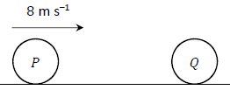The coefficient of restitution between the spheres is $\frac{3}{8}$.

1. Calculate the velocity of 𝑃 and the velocity of 𝑄 after impact.
2. Calculate, in terms of 𝑚, the loss in kinetic energy due to the impact.

**2023 OL Question 7**

A small smooth sphere, 𝑆1, of mass 6 kg is projected with a velocity of 3 m s–1 along a smooth horizontal surface and collides with second small smooth sphere, 𝑆2, of mass 4 kg travelling in the same direction with a velocity of 1.5 m s–1.

The coefficient of restitution between the spheres is $\frac{2}{3}$.

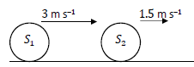

1. Calculate the velocity of 𝑆1 and the velocity of 𝑆2 after impact.
2. Calculate the total kinetic energy of the system before impact.
3. Calculate the loss in kinetic energy as a result of the impact.

After the collision, 𝑆2 travels a distance of 80 cm at constant velocity before it decelerates to rest while travelling a further distance of 50 cm.

1. Calculate the time interval between the collision and when 𝑆2 comes to rest.

**2023 HL Question 2 (b)**

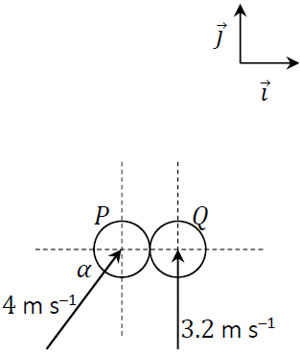Two smooth spheres, 𝑃 and 𝑄, have equal radius and are of mass 𝑚 and 2𝑚 respectively.   
𝑃 and 𝑄 collide obliquely.

The line joining their centres at the point of impact lies along the 𝚤⃗ axis.

Before the collision, sphere 𝑃 moves with a velocity of 4 m s–1 at an angle 𝛼 with the 𝚤⃗ axis, where $\sin{α}=\frac{4}{5}$.

Before the collision, sphere 𝑄 moves with a velocity of 3.2 m s–1 perpendicular to the 𝚤⃗ axis.

The coefficient of restitution between the spheres is 𝑒, where

0 ≥ 𝑒 ≤ 1.

Calculate, in terms of 𝑒, the velocity of each sphere immediately after they collide.

**2023 HL Deferred Question 7**

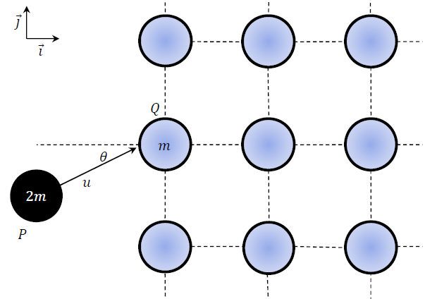A solid can be modelled as a two‐dimensional lattice of identical particles of mass 𝑚.

A particle of the solid may be moved temporarily out of its position but it is quickly returned to that position by the forces that hold the solid together.

An incoming particle 𝑃 of mass 2𝑚, moving with speed 𝑢, collides obliquely with particle 𝑄 which is at rest on the outer surface of the solid.

The line joining the centres of the particles at the point of impact is along the 𝚤⃗ axis.

Before the collision, the direction of 𝑃 makes an angle 𝜃 with the 𝚤⃗ axis.

After the collision the direction of 𝑃 has turned through an angle 𝜃, such that it now makes an angle 2𝜃 with the 𝚤⃗ axis.

The coefficient of restitution for the collision is $\frac{2}{3}$.

1. Show that tan 𝜃 = $\frac{1}{3}$
2. Calculate the 𝚤⃗ and 𝚥⃗ components of the velocity of 𝑄 immediately after the collision in terms of 𝑢.

**Sample Paper HL Question 4 (b)**

Two identical smooth spheres, 𝑃 and 𝑄, each moving with speed 𝑢, collide obliquely.

The line joining their centres at the point of impact is along the 𝚤⃗ axis.

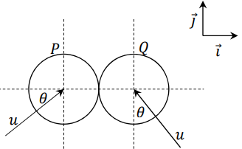Before the collision, the velocity of sphere 𝑃 makes an angle 𝜃 with the 𝚤⃗ axis and the velocity of sphere 𝑄 makes an angle 𝜃 with the 𝚥⃗ axis, as shown in the diagram.

The coefficient of restitution between the spheres is 𝑒, where 0 ≤ 𝑒 ≤1.

After the collision sphere 𝑄 moves off parallel to the 𝚥⃗ axis.

1. Show that $e=\frac{\tan{θ-1}}{\tan{θ+1}}$
2. If 25% of the spheres’ total kinetic energy is lost during the collision, calculate 𝜃 and 𝑒.

# Work done on a stretched string

**Sample Paper HL Question 7 (a)**

A bungee jumper of mass 75 kg jumps from a height of 35 m above water.

The jumper is tied to an elastic rope of natural length 12 m and elastic constant 100 N m–1.

(i) Derive an expression for the work done when a spring of elastic constant 𝑘 N m–1 is stretched by 𝑥 m.

1. The motion of the bungee jumper may be modelled using the principle of conservation of energy.   
   Using this model, calculate the distance between the water and the bungee jumper when the bungee jumper is at the lowest point of their motion.

**2023 HL Deferred Question 7**

After the collision 𝑄 experiences a restoring force 𝐹 which is proportional to 𝑥, the displacement of 𝑄 from its initial position, where 𝑘 is the constant of proportionality. (That is, the restoring force may be modelled as being equivalent to the restoring force exerted on a particle by a spring of spring constant 𝑘 stretched through displacement 𝑥.)

1. Derive an expression for the work done when 𝑄 moves through displacement 𝑥.
2. Find the maximum displacement of 𝑄 from its initial position in terms of 𝑚, 𝑘 and 𝑢.

# Circular motion

## Horizontal circular motion

**2023 OL Question 2 (a)**

A piece of clay of mass 0.335 kg rests on a horizontal potter’s wheel, which is rotating with period 𝑇 = 1.2 s.

The clay moves with uniform circular motion of radius 𝑟.

The coefficient of friction between the wheel and the clay is ½.

1. Draw a labelled diagram to show the forces acting on the clay.
2. 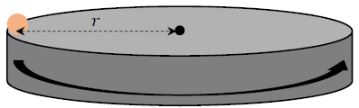Calculate the force of friction that acts on the clay.
3. Calculate 𝜔, the angular velocity of the clay.
4. Calculate the value of 𝑟.

**2023 OL Question 2 (b)**

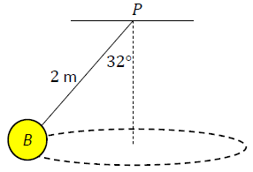Ball 𝐵, of mass 5.5 kg, is connected to a fixed point 𝑃 by a light inextensible string of length 2 m.   
  
The ball moves in a horizontal circle, where the centre of the circle is vertically below 𝑃.   
  
The string makes an angle of 32° with the vertical, as shown in the diagram.

1. Draw a labelled diagram to show the forces acting on 𝐵.
2. Calculate the tension in the string.
3. Calculate 𝜔, the angular velocity of the ball.

**Sample Paper HL Question 6**

A learner driver is practising driving around a roundabout.

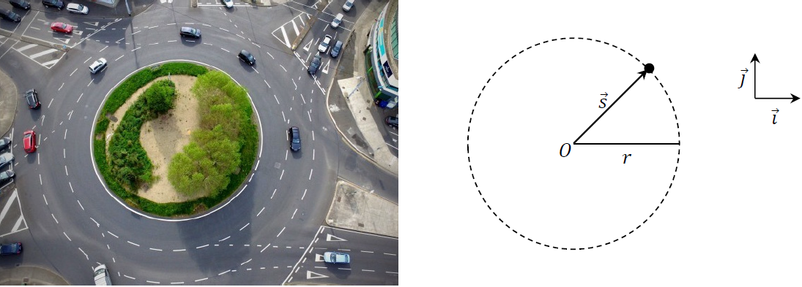

The motion of the car may be modelled as horizontal circular motion around centre 𝑂, with radius 𝑟 and constant angular speed 𝜔, as in the diagram above.

1. Write an expression for 𝑠, the displacement of the car relative to 𝑂 at any time 𝑡, in terms of 𝑟, 𝜔 and 𝑡. Your expression should use the unit vectors 𝚤⃗ and 𝚥⃗.

Note that *t* = 0 when 𝑠⃗ is along the 𝚤⃗ axis.

1. Derive an expression for 𝑣⃗, the velocity of the car at any time 𝑡.
2. Use a dot product calculation to show that the car’s velocity and displacement are always perpendicular to each other.
3. Show that the acceleration of the car is always directed towards 𝑂.
4. Derive an expression for the maximum velocity the car could have as it travels around the roundabout, without slipping. Your expression should be written in terms of 𝑟, 𝑔 and 𝜇, the coefficient of friction between the car and the road.
5. Use dimensional analysis to show that the units for the expression you derived in part (v) are equivalent to the units for velocity.
6. Do you think the assumptions made in developing this model were appropriate?

Explain your answer.

**2023 HL Question 3**

The photograph on the right is of a chain swing ride in an amusement park. The disk at the top of the ride is rotating in a horizontal plane.

People sit in seats which are attached freely by inextensible chains of length 4.3 m to fixed points on the disk.

The chain attaching seat 𝐴 hangs from point 𝑋 on the ride and makes an angle 𝛼 with the vertical. 𝑋 is 3.5 m from the axis of rotation, which is the vertical line 𝑃𝑄, as shown in the diagram below.

The chain is free to swing in or out relative to 𝑃𝑄.

The ride rotates about 𝑃𝑄 with constant angular velocity 𝜔.   
Seat 𝐴 moves in a horizontal circular path which is 6 m above the ground.



1. Draw a diagram to show the external forces acting on seat 𝐴.
2. Show that $ω=\sqrt{\frac{g \tan{α}}{3.5+4.3 \sin{α}}}$
3. It is found by measurement that 𝛼 = 25°.

Calculate how many complete revolutions the ride makes in one minute.

1. The person sitting in seat 𝐴 throws a small orange into the air. The person imparts an upward vertical velocity component of 4 m s–1 to the orange.

Calculate the time from when the orange is thrown until it hits the ground.

**2023 HL Deferred Question 1 (b)**

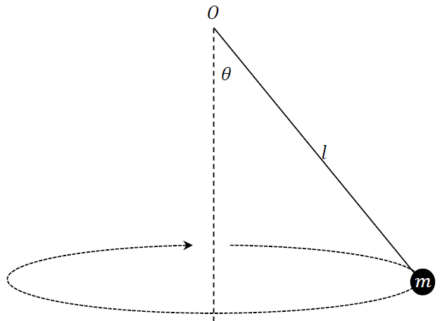A spherical bob of mass 𝑚 is attached to a light inextensible string of fixed length 𝑙. It is suspended from support point 𝑂.

The string makes an angle 𝜃 with the vertical. The bob moves through a horizontal circle which has its centre on the vertical. The bob has constant linear speed 𝑣.

1. Show on a diagram the forces acting on the bob.
2. Derive an expression for 𝑣 in terms of 𝑙, 𝜃 and 𝑔, the acceleration due to gravity.
3. Derive an expression for 𝑇, the period of rotation of the bob, in terms of 𝑙, 𝜃 and 𝑔.
4. Use dimensional analysis to show that the units for the expression you derived in part **(***iii***)** are equivalent to the units for period.

## Vertical circular motion

**Sample paper Ordinary Level Question 1 (b)**

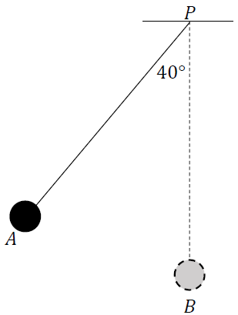A small smooth sphere of mass 2 kg is connected by a light inextensible string of length 3 m to a fixed point 𝑃.   
The sphere is held at position 𝐴, where the taut string makes an angle of 40° to the vertical, as shown in the diagram. The sphere is then released from rest.

The motion of the sphere may be modelled using the principle of conservation of energy.

1. Using this model, calculate the speed of the sphere as it passes through position 𝐵, when the string is vertical.
2. Calculate the centripetal force on the sphere as it passes through 𝐵.
3. Calculate the tension in the string when the sphere passes through 𝐵.

**2023 HL Question 10 (b)**

A toy car track consists of a series of components that connect to make a closed circuit.

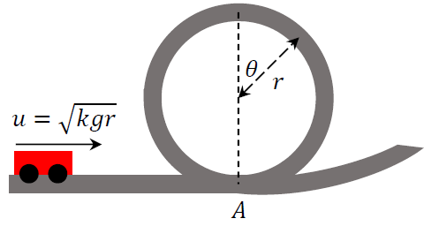Part of the track makes a vertical circular loop.

To model the motion of a car on this track, its velocity at the base of the loop (point 𝐴) is expressed as $u=\sqrt{kgr}$, where 𝑟 is the radius of the loop, 𝑔 is the acceleration due to gravity, and 𝑘 is a constant.

The model ignores the effects of friction.

1. Draw a diagram to show the forces acting on the car at the instant when the radius to the car makes an angle 𝜃 with the upward vertical.
2. If the car loses contact with the track at the instant when the radius to the car makes an angle 𝜃 with the upward vertical, show that $\cos{θ=\frac{k-2}{3}}$.
3. Calculate the minimum value of 𝑘 such that the car successfully completes the loop without losing contact with the track.

**2023 HL Deferred Question 10**

A smooth cylinder of radius 1.5 m lies on its side in a fixed position on horizontal ground.

A diagram of a circular cross‐section of the cylinder is shown below. The point of contact of the cylinder with the ground is fixed at point 𝑃.

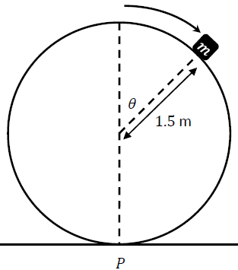A small object of mass 𝑚 rests on the highest point of the cylinder, vertically above 𝑃. The object is slightly disturbed from rest so that it begins to slide down the cylinder. As it slides it makes an angle 𝜃 with the vertical, as shown in the diagram.

A student wishes to model the initial motion of the object as motion in a vertical circle.

1. Outline the assumptions made by the student’s model.
2. Calculate the value of 𝜃 when the object leaves the surface of the cylinder.
3. Calculate the velocity of the object when it leaves the surface of the cylinder.

The student models the motion of the object after it leaves the surface of the cylinder as projectile motion in a uniform gravitational field.

1. Calculate the time between when the object leaves the surface of the cylinder and when it lands on the ground.
2. Calculate the horizontal distance between point 𝑃 and the point where the object lands on the ground.

# Difference Equations

## First Order Difference Equations – Ordinary level

**Ordinary level Sample paper 2023 Question 5 (b)**

A tennis ball bounces across a tennis court. It is found that some of the ball’s kinetic energy is lost each time it hits the ground, such that the horizontal range, 𝑅, of each bounce is 70% of the range of the previous bounce.

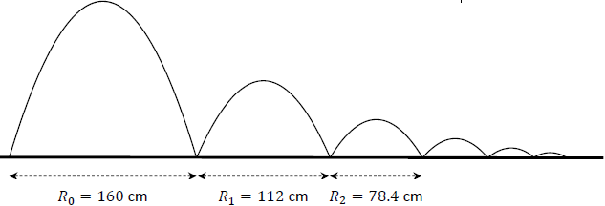The ranges of the first three bounces are given in the diagram below.

This geometric sequence may be represented by the difference equation:

𝑅*n*+1 = 0.7𝑅*n*.

where 𝑛 ≥ 0, 𝑛 ∈ ℤ and 𝑅0 = 160 cm.

1. Solve this difference equation to find an expression for 𝑅*n* in terms of 𝑛.
2. Calculate 𝑅6 in cm, to two decimal places.
3. Calculate 𝑆6, the sum of the ranges of the first seven bounces, in cm, to two decimal places.
4. Write a difference equation for the horizontal ranges of the bounces if no kinetic energy is lost when the ball hits the ground.

**Ordinary level paper 2023 Question 1 (b)**

Claire is an Applied Mathematics student and she wishes to model the rate at which a block of ice of mass 2 kg will melt.

Claire’s model assumes that the block of ice will lose 8% of its mass through melting every hour.

She calculates the mass (𝑀*n*) of the solid ice remaining after 𝑛 hours. Some of these values are shown in the table below, to 2 decimal places.

|  |  |  |  |  |  |
| --- | --- | --- | --- | --- | --- |
| 𝑛 (hours) | 𝑛 = 0 | 𝑛 = 1 | 𝑛 = 2 | 𝑛 = 3 | n = 4 |
| 𝑀*n* (kg) | 2.00 | 1.84 | 1.69 |  |  |

1. Calculate 𝑀3, the mass of ice remaining when 𝑛 = 3 hours, and 𝑀*4*, the mass of ice remaining when 𝑛 = 4 hours.

According to Claire’s model, the values of 𝑀*n* are a geometric sequence which may be represented by the difference equation:

𝑀*n*+1 = 0.92𝑀*n*

where 𝑛 ≥ 0, 𝑛 ∈ ℤ and 𝑀0 = 2.00 kg.

1. Explain how Claire derived this difference equation.
2. Calculate the total mass of ice lost through melting when 𝑛 = 6 hours.
3. Calculate the smallest value of 𝑛 such that the block of ice has a mass of less than 1 kg.

**Ordinary level paper 2023 Question 8 (a)**

Kevin takes out a loan of €12 000 to purchase a new car. Kevin will repay the same amount, €𝐴, at the end of each month for 60 months. An interest rate of 0.69% is applied to the amount he owes every month.

𝑈, the amount in € that Kevin owes after 𝑛 months, may be modelled by the difference equation:

*Un*+1 = 1.0069*Un* - A

where 𝑛 ≥ 0, 𝑛 ∈ ℤ and 𝑈0 = €12 000

1. Solve the difference equation to find an expression for 𝑈n, the amount that Kevin owes after 𝑛 months, in terms of 𝑛 and 𝐴.
2. Calculate the value of 𝐴, the repayment made by Kevin at the end of each month, so that the loan is repaid in full after 60 months.

**Ordinary level Sample paper 2023 Question 3 (a)**

Kate wishes to invest €150 000 in a long‐term investment scheme. Cormac is an investment broker. He offers Kate a guaranteed annual interest rate of 5.2% on her investment.

However Cormac will charge an annual fee of €3000, which will be deducted from her investment.

The value, 𝑃, in €, of Kate’s investment after 𝑛 years may be modelled by the difference equation:

𝑃*n*+1 = 1.052𝑃*n* – 3000

where 𝑛 ≥ 0, 𝑛 ∈ ℤ and 𝑃0 = 150 000.

1. Solve this difference equation to find an expression for 𝑃*n*, the value of Kate’s investment after 𝑛 years if she invests with Cormac.
2. Calculate 𝑃6, the value of Kate’s investment after 6 years if she invests with Cormac.
3. Ruth, another investment broker, offers Kate a guaranteed annual interest rate of 4.3%.

Ruth will charge an annual fee of €2000.

Kate wishes to maximise the value of her investment after 6 years.   
With which broker, Cormac or Ruth, should Kate invest? Justify your answer.

## First Order Difference Equations – Higher level

**Sample Paper HL Question 8**

Note that this question has been edited (the original question also incorporated Differential equations).

The full question appears later in this booklet.

A group of scientists are investigating the population, 𝑃, of rabbits on a certain island. They estimate that there are 8000 rabbits on the island and that the population is growing at a constant rate of 3% per year.

The scientists plan to remove a number of rabbits from the island every year, to help populate another habitat. They develop mathematical models to predict how 𝑃 will change if 𝐵 rabbits are removed from the island every year.

The first model which the scientists develop uses a difference equation to express the population of rabbits in year 𝑛+1 in terms of the population in year 𝑛.

The difference equation is:

Pn+1 = 1.03Pn - B

where 𝑛 0, 𝑛∈ℤ and 𝑃0 = 8000.

1. Solve this difference equation to find an expression for 𝑃n in terms of 𝑛 and 𝐵.

The scientists want to know what this model predicts the rabbit population on the island will be after 50 years, if 200 rabbits are removed each year.

1. Calculate 𝑃50 when 𝐵 = 200.
2. This models makes an assumption about the removal of the rabbits from the island.   
   What is that assumption?
3. The scientists want to know what value of 𝐵 should be chosen so as to keep the rabbit population on the island constant. Calculate this value of 𝐵.

**2023 HL Question 10 (a)**

An entomologist (a scientist who studies insects) maintains a population of grasshoppers in her laboratory.

The entomologist’s research tells her that the population of this species of grasshopper should increase by a factor of 1.2 each month if they are left undisturbed. However the entomologist removes 30 grasshoppers from the population each month, to carry out research on them.

The entomologist develops a difference equation model to predict 𝑈n, the number of grasshoppers present at the beginning of month 𝑛.

At the start of the first month the entomologist has 175 grasshoppers, i.e. 𝑈0 =175.

1. Calculate the values of 𝑈1 and 𝑈2.
2. Write down a difference equation to express 𝑈n+1 in terms of 𝑈n, where 𝑛 ≥ 0, 𝑛 ∈ ℤ.
3. Solve this difference equation to find an expression for 𝑈n in terms of 𝑛.
4. Calculate 𝑈12, the number of grasshoppers which the model predicts will be in the population after one year.

**2023 Deferred HL Question 2 (b)**

In another, larger computer network, a message travels from one computer to another in the network. Each time a message travels from one computer to the next the number of errors in the message, 𝐸, increases by 15%. However 𝐶 errors are corrected each time the message travels. The number of computers the message travels to is counted using the number 𝑛.

A message starts at computer 𝑛 = 0 and travels on a linear path through the computer network.

𝐸, the number of errors in the message, may be modelled by the difference equation:

*E*n+1 = 1.15*E*n - C

where 𝑛 ≥ 0, 𝑛 ∈ ℤ.

There are 101 errors in the message when it leaves computer 0, i.e. 𝐸0 =101.

1. Solve this difference equation to find an expression for 𝐸*n* in terms of 𝑛 and 𝐶.
2. It is found that the message contains zero errors after it reaches the 21st computer, i.e. 𝐸*21* = 0.   
   Calculate the value of 𝐶 to the nearest whole number.
3. 𝐸 may also be modelled using a differential equation. Write a differential equation for $\frac{dE}{dn}$, the rate of change of 𝐸 with respect to 𝑛, in terms of 𝐸 and 𝐶.

## Second Order Homogeneous Difference Equations – Ordinary level

**Ordinary level paper 2023 Question 8 (b)**

Pike is a species of freshwater fish. 𝑃, the population of pike in a certain river, is affected by the level of pollution in the river.

At the start of 2020, the local community attempted to clean up the river and remove the pollution.

To assess if the community was successful, a zoologist measured the population of pike in 2020 and again in 2021.

In 2020 (𝑛 = 0) 8 pike were observed. In 2021 (𝑛 = 1) 14 pike were observed.

The zoologist predicts that the population of pike in any year is equal to twice the population in the previous year plus eight times the population in the year before that. This predication can be expressed as the second‐order difference equation:

*Pn*+2 – 2*Pn*+1 – 8*Pn* = 0

where 𝑛 ≥ 0, 𝑛 ∈ ℤ, *P*0 = 8 and *P*1 = 14.

This difference equation has the characteristic quadratic equation 𝑥2 - 2𝑥 - 8 = 0.

1. Solve this quadratic equation, i.e. calculate the two roots of the equation.
2. Hence or otherwise, solve the difference equation to find an expression for 𝑃*n* in terms of 𝑛.

Calculate the number of pike that the model predicts will be present in 2026.

**Ordinary level Sample paper 2023 Question 3 (b)**

A car dealership began to sell a new type of electric car in January 2020. The dealership sold eight of these cars in 2020. It sold twelve of them in 2021.

A sales person predicts that 𝑈, the number of such cars sold in any year, will be equal to twice the number of cars sold in the previous year plus three times the number of cars sold the year before that.

This prediction can be expressed as the second‐order difference equation:

*Un*+2 -2*Un*+1 - 3*Un*= 0

where 𝑛 ≥ 0, 𝑛 ∈ ℤ and *U*0 = 8 and *U*1 = 12.

This difference equation has the characteristic quadratic equation 𝑥2 - 2𝑥 - 3 = 0.

1. Solve this quadratic equation, i.e. calculate the two roots of the equation.
2. Hence or otherwise, solve the difference equation to find an expression for 𝑈*n* in terms of 𝑛.
3. Calculate the number of such cars that the model predicts the dealership will sell between the start of 2020 and the end of 2025.

## Second Order Homogeneous Difference Equations – Higher level

**Higher level Sample paper Question 1 (b)**

A gardener plants a new fruit tree which has three new branches. In a branch’s first year of growth it will not produce any additional branches.

Each branch will produce one additional branch every year after that.

The gardener models this growth pattern by defining 𝑈*n* to be the number of branches on the tree 𝑛 years after planting, with 𝑈0 = 3 and 𝑈1 = 3.

1. Write down the values of 𝑈2 and 𝑈3.
2. Write down a difference equation for 𝑈*n*+2in terms of 𝑈*n*+1and 𝑈*n*where 𝑛 ≥ 0, 𝑛∈ℤ
3. Solve this difference equation to find an expression for 𝑈n in terms of 𝑛.
4. Plants must be cut back regularly to allow them room to grow.   
   How many of the old branches should be removed at the end of year 4 to ensure that there are exactly 14 branches at the end of year 5?

## Second Order Inhomogeneous Difference Equations – Higher level

**Higher level paper 2023 Question 6**

Spider plants (*Chlorophytum comosum*) can reproduce asexually, producing new plants called

‘spiderettes’ or ‘pups’. The manager of a garden centre is told that a one year old spider plant produces two pups each year, that a two year old spider plant produces three pups each year, and that spider plants which are less than one year old or more than two years old do not produce any pups.

The manager predicts that 𝑈, the number of pups produced in the garden centre in any year can be expressed by the second‐order homogeneous difference equation:

𝑈*n*+2 = 2𝑈*n*+1 + 3𝑈*n*

where 𝑛 ≥ 0, 𝑛 ∈ ℤ, 𝑈0 = 1 and 𝑈1 = 2.

1. Write down the values of 𝑈2 and 𝑈3.
2. Solve the difference equation to find an expression for 𝑈*n* in terms of 𝑛.
3. Calculate 𝑈10.

The manager realises that this model does not take into account the sale of any of the spider plants produced in the garden centre. The manager decides that the garden centre will not sell any of the spider plants in either of the first two years, but that 2𝑛 of the new pups will be sold in each year 𝑛 after that.

As part of an improved model, the manager now predicts that 𝑉, the number of pups produced and retained (not sold) in the garden centre in any year can be expressed by the second‐order inhomogeneous difference equation:

*Vn*+2 = 2*Vn*+1 + 3*Vn* -2(n+2)

where 𝑛 ≥ 0, 𝑛 ∈ ℤ, 𝑉0= 1 and 𝑉1 = 2.

1. Solve this new difference equation to find an expression for 𝑉*n* in terms of 𝑛.
2. Calculate 𝑉10.

**2023 Deferred HL Question 3**

In an economic model, the gross national income 𝐺 of a country, consists of three separate contributions:

𝐺 = 𝑃 + 𝐼 + 𝑆

where 𝑃 represents private spending by citizens, 𝐼 represents investment in the economy, and 𝑆 represents government spending.

𝐺 can be modelled using a difference equation, where 𝑃 and 𝐼 change each year 𝑛 and where 𝑆 is assumed to be constant. That is:

𝐺n = 𝑃n + 𝐼n + 𝑆

In any year, 𝑃 is proportional to the value of 𝐺 for the previous year. That is:

𝑃n+1 = 𝑎𝐺n

where 𝑛 ≥ 0, 𝑛 ∈ ℤ and $α=\frac{15}{16}$

In any year, 𝐼 is proportional to the change in the value of 𝑃 between that year and the previous one. That is:

*I*n+1 = *b*(𝑃n+1  - *P*n)

where 𝑛 ≥ 0, 𝑛 ∈ ℤ and $b=\frac{3}{5}$

1. Use this information to form a second‐order inhomogeneous difference equation for 𝐺 and express it in the form:

𝐺n+2 + *cG*n+1 + *dG*n = 𝑆

for the constants 𝑐, 𝑑 which are to be determined.

Calculate the values for 𝑐 and 𝑑.

1. Assuming the government spends no money (i.e. assuming 𝑆 = 0 euro), 𝐺 can be expressed by the second‐order homogeneous difference equation:

𝐺n+2 + *cG*n+1 + *dG*n = 0

Using 𝐺0 = 840 and 𝐺1 =820 in billions of euros, solve this difference equation to find an expression for 𝐺*n* in terms of 𝑛.

Calculate 𝐺6 to the nearest billion euros.

1. Assuming the government spends 40 billion euros each year (i.e. assuming 𝑆 = 40 in billions of euros), 𝐺 can be expressed by the second‐order inhomogeneous difference equation:

𝐺n+2 + *cG*n+1 + *dG*n = 40

Again using 𝐺0 = 840 and 𝐺1 =820 in billions of euros, solve this difference equation to find an expression for 𝐺n in terms of 𝑛.

Again calculate 𝐺6 to the nearest billion euros.

# Differential equations

**Sample Paper HL Question 7 (a)**

Derive an expression for the work done when a spring of elastic constant 𝑘 N m–1 is stretched by 𝑥 m.

**2023 HL 2023 Question 1 (b)**

A particle moving along a straight line has velocity $v=\frac{ds}{dt}=2te^{-t}$, $t≥0$.

1. Using integration by parts or otherwise, derive an expression for (𝑡), the displacement of the particle at any time 𝑡, given that 𝑠(0) = 0.
2. Calculate (3).

**Sample Paper HL Question 3 (a)**

A particle has initial displacement 𝑠0 from a fixed point 𝑃.

It moves away from 𝑃 with initial velocity 𝑢 and constant acceleration $a=\frac{dv}{dt}=\frac{d^{2}s}{dt^{2}}$.

Use calculus to derive an expression for 𝑠, the displacement of the particle from 𝑃 at any time 𝑡.

**2023 HL Question 4**

A ball of mass 𝑚 kg is projected with initial velocity 15 m s–1 vertically downwards into a tank of water. The ball travels through the water against an upward buoyancy force that is 4 times the magnitude of the weight of the ball and a drag force of 𝑚𝑣2 N.

1. Draw a diagram to show the forces acting on the ball while it is moving downwards through the water.
2. Show that, while the ball is moving downwards, the rate of change of its velocity 𝑣 with respect to its distance 𝑠 below the surface of the water can be expressed by the differential equation:
$$v\frac{dv}{ds}=-29.4-v^{2}$$

3. Solve this differential equation to find an expression for 𝑣 in terms of 𝑠.
4. The ball is at its maximum depth, 𝐷, when 𝑣 = 0. Calculate 𝐷.
5. After reaching its maximum depth the ball changes direction and begins to move upwards through the water.

Draw a diagram to show the forces acting on the ball while it is moving upwards through the water.

1. Write down a differential equation for the rate of change of the velocity 𝑣 of the ball while it moves upwards through the water.

**2023 HL Deferred Question 5**

1. A ball is thrown vertically upwards from the edge of a building that is 24.5 m high.

The ball reaches its maximum height 2 s after it is thrown.   
Using a model that neglects the effects of air resistance, calculate the time from when the ball is thrown to when it lands on the ground at the bottom of the building.

1. A more sophisticated model for the motion of a ball that is thrown vertically upwards includes the effects of air resistance. The rate of change of the velocity 𝑣 of the ball in terms of time 𝑡 during the upward part of its journey can be modelled by the following differential equation:

$$\frac{dv}{dt}=-g-kt$$

where 𝑘 > 0 is a constant. Take the initial upward velocity of the ball to be 20 m s–1.

Solve this differential equation to find an expression for 𝑣 in terms of 𝑡 and 𝑘.

1. Using 𝑘 = 0.1225, calculate the time the ball takes to reach its maximum height.
2. Write down a differential equation for the rate of change of the velocity of the ball on the downward part of its journey.

**2023 HL Deferred Question 4**

In 1838 the Belgian mathematician Pierre François Verhulst published a differential equation to model rate of change of population 𝑃 with respect to time 𝑡:

$$\frac{dP}{dt}=rP(1-\frac{P}{K})$$

where 𝑟 and 𝐾 are constants for a given population.

For a certain species of insect in an environment it is known that the population can increase by up to 8% per week, i.e. 𝑟 = 0.08.

At 𝑡 = 0 weeks there are 20 insects in the population.

When the population 𝑃 is small relative to 𝐾, the ratio $\frac{P}{K}$ is also small and Verhulst’s model can be approximated by the simplified differential equation:

$$\frac{dP}{dt}=rP$$

1. Solve this simplified differential equation to find an expression for 𝑃 in terms of 𝑡.
2. Calculate 𝑃 to the nearest whole number when 𝑡 = 12 weeks.
3. Explain why this approximation of Verhulst’s model is not practical for predicting the long‐term behaviour of the population of insects.
4. Solve the differential equation for Verhulst’s model: $$\frac{dP}{dt}=rP(1-\frac{P}{K})$$

to find an expression that relates 𝑃, 𝐾 and 𝑡.

Note that $\frac{1}{y(x-y)}=\frac{1}{x}(\frac{1}{y}+\frac{1}{x-y})$

1. 𝑃 = 39 insects when 𝑡 = 12 weeks. Calculate the value of 𝐾 to the nearest whole number.
2. Explain the significance of 𝐾 in the Verhulst model.

**2023 HL Question 7 (b)**

A *learning curve* is a graphical representation of how a person’s ability to perform a certain task increases with the time the person spends learning or practicing that task.

A student wishes to be able to spell 2000 difficult words. The rate of the student’s learning may be modelled by the differential equation:

$$\frac{dN}{dt}=k(2000-N)$$

where 𝑁(𝑡) is number of these words the student is able to spell after 𝑡 hours of learning, and where 𝑘 is a positive constant.

At the start of their learning the student is already able to spell 250 of these words, i.e. (0) = 250.

1. Solve the differential equation to find an expression for 𝑁 in terms of 𝑘 and 𝑡.
2. After 6 hours of learning, the student is able to spell 1500 of these words. Calculate 𝑘.
3. Sketch the shape of a graph of 𝑁 against 𝑡 to show the model’s prediction for the student’s learning curve.
4. After 6 hours of learning, the student is able to spell 1500 of these words. Calculate 𝑘.
5. Sketch the shape of a graph of 𝑁 against 𝑡 to show the model’s prediction for the student’s learning curve.

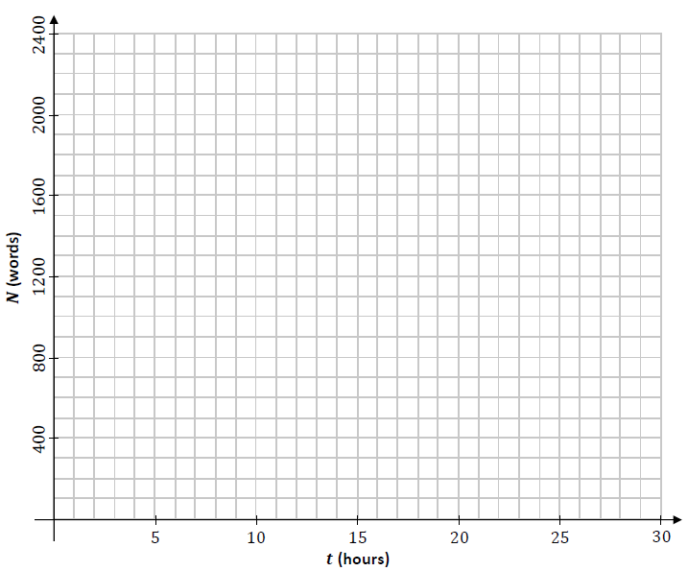

**Sample Paper HL Question 5 (b)**

A rumour may be spread when a person who has heard the rumour interacts with a person who has not heard the rumour.

Therefore, the rate of spread of a rumour within a group can be modelled as being proportional to the product of the number of people in the group who have heard the rumour and the number of people in the group who have not heard it.

A student models the rate at which a certain rumour spreads within a school population of 1200 students using the differential equation:

$$\frac{dR}{dt}=kR(1200-R)$$

where 𝑅(t) is the number of students of that school who have heard the rumour at time 𝑡, measured in days, and where 𝑘 is a positive constant.

On Monday morning (𝑡 = 100), 100 students had heard the rumour.

1. Solve the differential equation to find an expression that relates 𝑅, 𝑘 and 𝑡.

Note that $\frac{1}{y(x-y)}=\frac{1}{x}(\frac{1}{y}+\frac{1}{x-y})$

1. By Wednesday morning 250 students had heard the rumour. Calculate the value of 𝑘.
2. Sketch the shape of a graph of 𝑅 against 𝑡 to show how the model predicts the spread of the rumour.

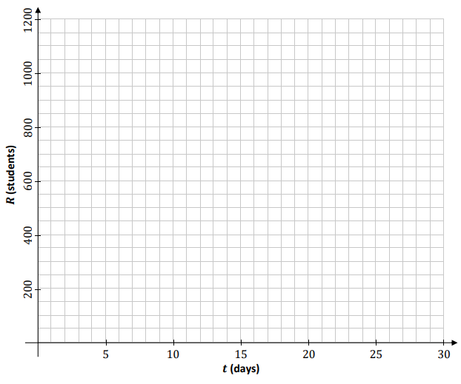

## Integration and differentiation

**Sample Paper HL Question 6**

A learner driver is practising driving around a roundabout.



The motion of the car may be modelled as horizontal circular motion around centre 𝑂, with radius 𝑟 and constant angular speed 𝜔, as in the diagram above.

1. Write an expression for $\vec{s}$, the displacement of the car relative to 𝑂 at any time 𝑡, in terms of 𝑟, 𝜔 and 𝑡.   
   Your expression should use the unit vectors 𝚤⃗ and 𝚥⃗.

Note that *t* = 0 when 𝑠⃗ is along the 𝚤⃗ axis.

1. Derive an expression for 𝑣⃗, the velocity of the car at any time 𝑡.
2. Use a dot product calculation to show that the car’s velocity and displacement are always perpendicular to each other.
3. Show that the acceleration of the car is always directed towards 𝑂.
4. Derive an expression for the maximum velocity the car could have as it travels around the roundabout, without slipping. Your expression should be written in terms of 𝑟, 𝑔 and 𝜇, the coefficient of friction between the car and the road.
5. Use dimensional analysis to show that the units for the expression you derived in part *(v*) are equivalent to the units for velocity.
6. Do you think the assumptions made in developing this model were appropriate?

Explain your answer.

## Difference equations and differential equations

**Sample Paper HL Question 8**

A group of scientists are investigating the population, 𝑃, of rabbits on a certain island. They estimate that there are 8000 rabbits on the island and that the population is growing at a constant rate of 3% per year.

The scientists plan to remove a number of rabbits from the island every year, to help populate another habitat. They develop mathematical models to predict how 𝑃 will change if 𝐵 rabbits are removed from the island every year.

The first model which the scientists develop uses a difference equation to express the population of rabbits in year 𝑛+1 in terms of the population in year 𝑛.

The difference equation is:

Pn+1 = 1.03Pn - B

where 𝑛 0, 𝑛∈ℤ and 𝑃0 = 8000.

1. Solve this difference equation to find an expression for 𝑃n in terms of 𝑛 and 𝐵.

The second model which the scientists develop uses a differential equation to express the rate of change of 𝑃 with respect to 𝑛, time measured in years.

The differential equation is:

$$\frac{dP}{dN}=0.03P-B$$

where 𝑛 $≥$ 0, 𝑛∈ℤ and 𝑃0 = 8000.

1. Solve this differential equation to find an expression for 𝑃 in terms of 𝑛 and 𝐵.

The scientists want to know what each model predicts the rabbit population on the island will be after 50 years, if 200 rabbits are removed each year.

1. Calculate 𝑃50 using the first model and 𝑃50 using the second model, when 𝐵 = 200.
2. Each of these models makes a different assumption about the removal of the rabbits from the island. What are the two different assumptions?
3. The scientists want to know what value of 𝐵 should be chosen so as to keep the rabbit population on the island constant. Calculate this value of 𝐵 using either model.

# Networks and Graphs

## Matrices and Adjacency matrices Ordinary Level

**Sample paper OL Question 7 (a)**

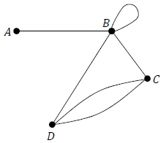Write the adjacency matrix that represents the graph shown below.

**Sample paper OL Question 7 (b)**

Matrix *P* = $\left[\begin{matrix}2 & 1 \\ 0 & 1\end{matrix}\right]$. Matrix *Q* = $\left[\begin{matrix}3 & 0 \\ -2 & 2\end{matrix}\right]$. Calculate *PQ*.

**2023 OL Question 1 (a)**

The diagram below shows a graph with five nodes, 𝐴, 𝐵, 𝐶, 𝐷 and 𝐸.

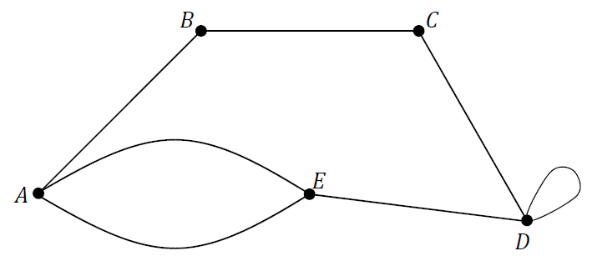

1. Write the adjacency matrix for this graph.
2. Matrix *A* = $\left[\begin{matrix}3 & 4 \\ -1 & -2\end{matrix}\right]$ and matrix *B* = $\left[\begin{matrix}-1 & 2 \\ 0 & 3\end{matrix}\right]$. Calculate *AB*.

## Matrices and Adjacency matrices Higher Level

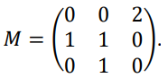**Sample Paper HL Question 1 (a)**

A directed graph is represented by the adjacency matrix

1. Draw the graph represented by 𝑀.
2. Calculate 𝑀2.
3. What information is provided by the elements of 𝑀2?

**2023 Deferred 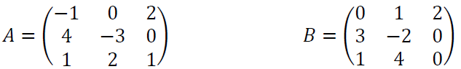Question 1**

1. 𝐴 and 𝐵 are two 3 × 3 matrices.
2. Calculate 𝐴𝐵.
3. 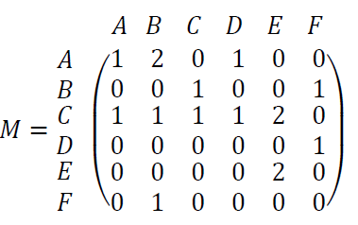Verify that 𝐴𝐵 $≠$ 𝐵𝐴.

**2023 HL Question 1 (a)**

A directed graph is represented by the adjacency matrix 𝑀, where

1. 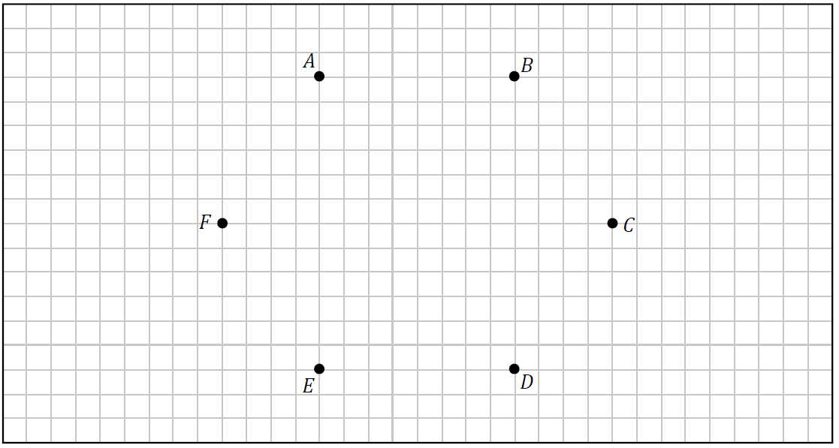Use the nodes below to draw a graph represented by 𝑀.
2. Write down a cycle which starts at node 𝐵.
3. How does a directed graph differ from an undirected graph?

## Minimum spanning trees: Kruskals and Prims algorithms Ordinary Level

**Sample paper OL Question 2 (a)**

During a treasure hunt competition, Seán must search at each of locations 𝐴, 𝐵, 𝐶, 𝐷 and 𝐸.

He may start at whichever of these location he chooses and he may visit the other locations in any order.

The estimated time, in seconds, needed to travel between any two of these locations is shown in the following table.

|  |  |  |  |  |  |
| --- | --- | --- | --- | --- | --- |
| Time (s) | A | B | C | D | E |
| A | - | 290 | 205 | 630 | 210 |
| B | 290 | - | 370 | 775 | 520 |
| C | 205 | 370 | - | 425 | 145 |
| D | 630 | 775 | 425 | - | 220 |
| E | 210 | 520 | 145 | 220 | - |

1. Draw a network to represent this information. On your network the weights of the edges should represent the times to travel between the locations, which should be represented by labelled nodes.
2. In order to win the competition, Seán wants to spend as little time as possible travelling between the locations.   
   Using an appropriate algorithm, find the minimum spanning tree for this network.

Name the algorithm you used. Relevant supporting work must be shown.

1. At which location should Seán start? Justify your answer.

**2023 OL Question 4 (a)**

In an effort to become more energy efficient, a university campus invests in upgrading its current heating system.

Each of the five buildings (Arts, Business, Cafeteria,

Design, Engineering) that are on the campus will require connection to this new heating system.

An engineer measures the underground distance, in m, between each of the buildings on the campus grounds.

She presents her results in the table below.

|  |  |  |  |  |  |
| --- | --- | --- | --- | --- | --- |
| Distance (m) | Arts | Business | Cafeteria | Design | Engineering |
| Arts | – | 300 | 650 | 525 | 190 |
| Business | 300 | – | 475 | 790 | 210 |
| Cafeteria | 650 | 475 | – | 425 | 145 |
| Design | 525 | 790 | 425 | – | 505 |
| Engineering | 190 | 210 | 145 | 505 | – |

1. Draw a network to represent this information. On your network the weights of the edges should represent the distances between each of the buildings, which should be represented by labelled nodes.
2. To help reduce costs, the engineer must minimise the length of pipework needed for this  
   heating system.  
   Using an appropriate algorithm, find the minimum spanning tree for this network. Name the algorithm you used. Relevant supporting work must be shown.
3. The pipes used are priced at €525 per metre. In addition, there is an installation cost of €6500 when any two buildings are connected by pipework.

Use your minimum spanning tree to calculate the total cost of this project.

## Minimum spanning trees: Kruskals and Prims algorithms Higher Level

**2023 HL Question 7 (a)**

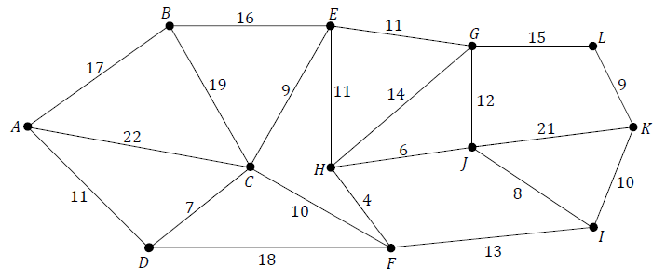There are 12 waterfalls in a certain national park. Paths allow visitors to walk from one waterfall to another. In the network shown below, the edges represent the paths and the nodes represent the waterfalls, labelled with the letters 𝐴 to 𝐿. The weight of each edge represents the time (in minutes) taken to walk between a pair of waterfalls.

The park authorities wish to plan a route along the paths which allows visitors to see every waterfall while moving through the park without wasting time. The paths that are not on this route will be closed.

1. Using an appropriate algorithm, find the minimum spanning tree for the network.

Name the algorithm you used. Relevant supporting work must be shown.

1. The park entrance is at waterfall 𝐴 and the park exit is at waterfall 𝐿. Using your minimum spanning tree, calculate the time needed to enter the park at waterfall 𝐴, visit every waterfall, and leave the park at waterfall 𝐿.

**Sample Paper HL Question 5 (a)**

In the network shown below, the edges represent roads and the nodes represent the junctions of two or more roads, labelled with the letters 𝐴 to 𝑁. The weight of each edge represents the distance (in km) between a pair of junctions.

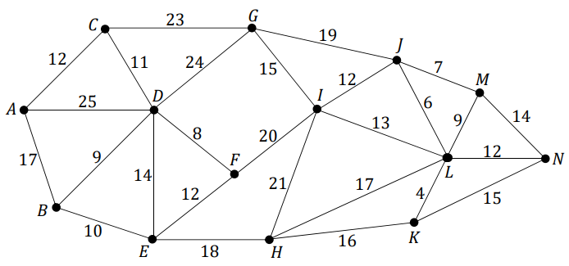

A group of engineers want to close down some of the roads to carry out maintenance work.

They wish to close down as much of the road network as possible while still allowing a person to drive between any two junctions on the network.

1. Using an appropriate algorithm, find the minimum spanning tree for the network.
2. Name the algorithm you used. Relevant supporting work must be shown.

**2023 Deferred Question 2 (a)**

Seven computers, 𝐴, 𝐵, 𝐶, 𝐷, 𝐸, 𝐹 and 𝐺, are part of a computer network. Each computer is connected to one or more of the other computers on the network. The time (in ms) for communication between each of the connected computers is given in the table below.

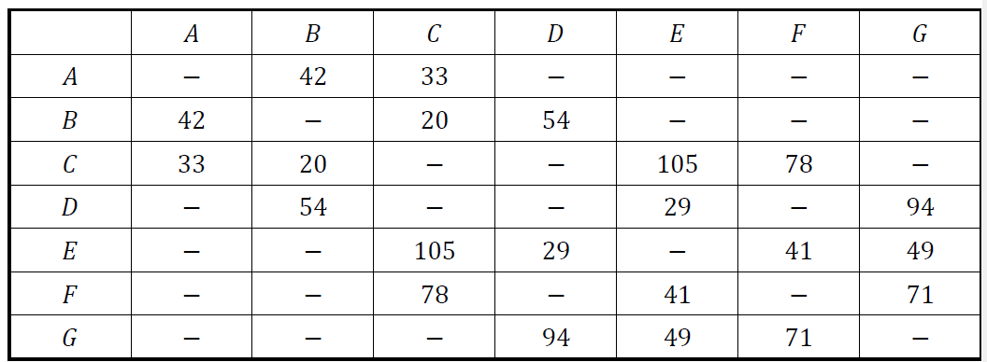

A computer scientist wishes to model this information using a weighted graph, where the nodes represent computers 𝐴 - 𝐺 and the weights of the edges represent the communication times between the connected computers.

1. Use the table above to draw a weighted graph to represent the computer network.
2. Calculate the shortest time for a message to travel from computer 𝐴 to computer 𝐺.   
   List the computers that the message travelled through, in order. Name the algorithm you used.

Relevant supporting work must be shown.

# Optimal Paths & Project Scheduling

## Dijkstra’s algorithm Ordinary Level

**2023 OL Question 4 (b)**

Mark is planning to visit South America.   
He plans to begin his visit in city 𝐴, and then travel across South America to meet some friends in city 𝐼.

Mark wishes to keep his travel costs to a minimum.

He wishes to calculate the cost of travelling to city 𝐼 by bus, travelling via some of the other cities, 𝐵 to 𝐻.

The cost, in €, of travelling by bus between various cities is shown in the network below. Mark does not intend on visiting all of the cities in his network.

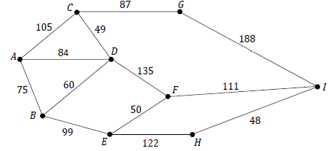

1. Use Dijkstra’s algorithm to find the cheapest bus route from city 𝐴 to city 𝐼.
2. Calculate the cost of the cheapest route. Relevant supporting work must be shown.

## Dijkstra’s algorithm Higher Level

**Sample Paper HL Question 5 (a)**

In the network shown below, the edges represent roads and the nodes represent the junctions of two or more roads, labelled with the letters 𝐴 to 𝑁. The weight of each edge represents the distance (in km) between a pair of junctions.

1. Use Dijkstra’s algorithm to find the shortest path from junction 𝐴 to junction 𝑁.
2. Calculate the length of the shortest path.   
   Relevant supporting work must be shown.

**2023 HL Question 2 (a)**

A university has decided to improve the paths on its campus. In the network shown below the nodes labelled with the letters 𝑋 and 𝑌 represent the two entrances to the campus and the nodes labelled with the letters 𝐴 to 𝑁 represent the key buildings on the campus.

The edges represent the paths, with the weight of each edge representing the cost (in €) of carrying out the improvement work for that path.

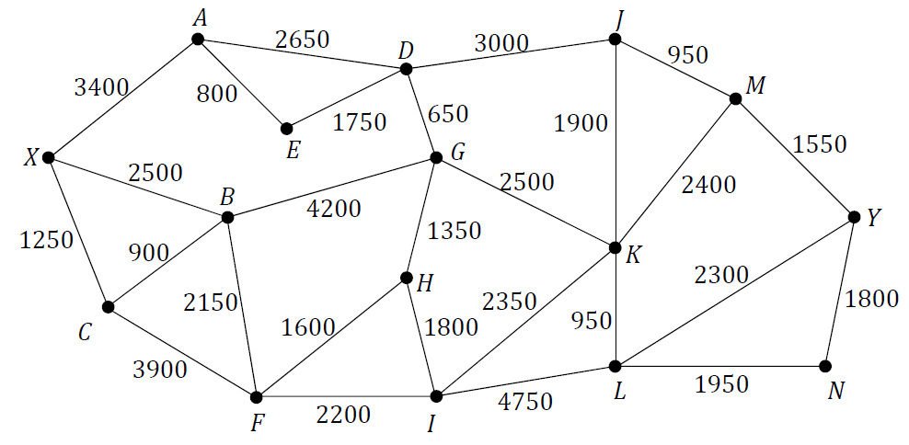The university decides that the first part of the work will be to provide an improved route between entrance 𝑋 and entrance 𝑌.

1. Use Dijkstra’s algorithm to find the route between 𝑋 and 𝑌 that is cheapest to improve.
2. Calculate the cost of carrying out such improvements.

Relevant supporting work must be shown.

## Early & Late times & Critical Paths: Ordinary Level

**Sample paper OL Question 2 (b)**

The diagram below shows the scheduling network used in the assembly of an air filtering system.

The edges of the network represent the activities that have to be completed as part of the assembly and are labelled with the letters 𝐴 to 𝐿. The letters used to label the edges should not be taken as representing the order in which the activities happen. The time, in minutes, to complete each of the activities is shown.

The nodes of the network represent events or points in time during the assembly.

The source node is the time when the project begins and the sink node is the time when the project ends.

1. Calculate the early time and the late time for each event.

Complete the diagram below by writing the early time (upper box) and late time (lower box) at the node representing each event.

Use the space below to show relevant supporting work, if necessary.

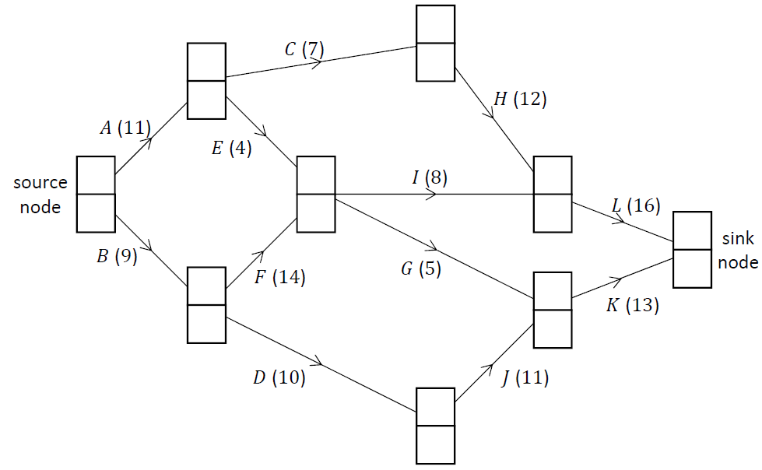

1. Write down the critical path for the network.
2. Write down the minimum time, in minutes, needed to assemble an air filtering system.
3. Select any one non‐critical activity on the network and calculate its float, in minutes.

**2023 OL Question 10**

The diagram below shows the scheduling network that an accounting company uses for processing an account. The edges of the network represent the activities that the workers need to carry out when processing an account and are labelled with the letters 𝐴 to 𝐿. The letters used to label the edges should not be taken as representing the order in which the activities happen.

The time, in minutes, to complete each of the activities is shown in brackets.

The nodes of the network represent events or points in time during the processing of an account.

The source node is the time when the processing begins and the sink node is the time when the processing ends.

1. Calculate the early time and the late time for each event.

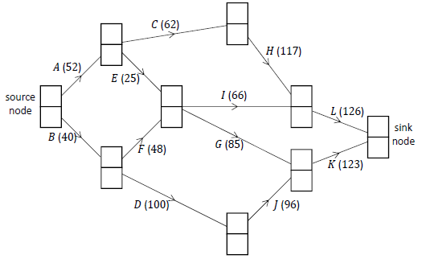Complete the diagram below by writing the early time (upper box) and late time (lower box) at the node representing each event.

Use the space below and on the next page to show relevant supporting work, if necessary.

1. Write down the critical path(s) for the network.
2. If the workers begin processing an account at 09: 30 a.m., calculate the earliest time when the work could be completed.
3. Calculate the float, in minutes, for activity 𝐼.
4. Exactly one hour after the processing of an account has begun, a supervisor checks the work.

State which activity (or activities) must be happening at this time. Justify your answer.

1. For a particular account, activity 𝐹 takes twice as long as usual. Does this cause a delay in the processing of the account? Justify your answer.

## Precedence tables PLUS Early & Late times & Critical Paths: Higher Level

**Sample Paper HL Question 2**

The diagram below shows the scheduling network for a project to manufacture a new chemical compound. The network provides some information about the relationships between the twelve activities that have to be completed as part of the project.

The edges of the network represent these activities and are labelled with the letters 𝐴 to 𝐿.

The unlabelled edges (shown with dashed lines) do not represent real activities but they help explain the order in which the activities must happen.

The letters used to label the edges should not be taken as representing the order in which the activities happen.

The nodes of the network represent events or points in time during the project.

The source node is the time when the project begins and the sink node is the time when the project ends.

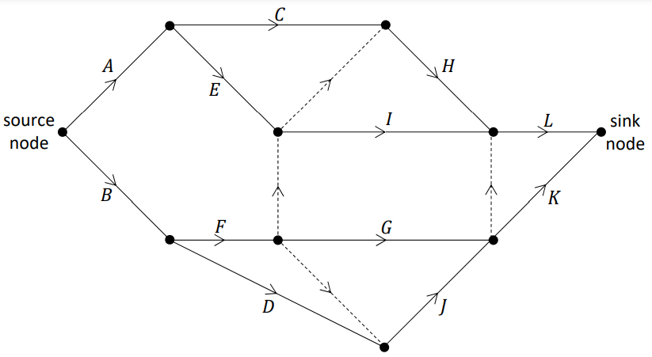

1. Complete the table on the next page by listing, for each activity, the other activities on which it depends directly. That is, for each activity 𝑋 ∈ $\left\{C, D, E, … , L\right\}$, write the smallest possible list of other activities which need to be completed before activity 𝑋 can begin.

Activities 𝐴 and 𝐵 do not depend on any prior activities, so the list is empty for these activities, as shown.

|  |  |
| --- | --- |
| Activity | Depends directly on . . . |
| A | - |
| B | - |
| C |  |
| D |  |
| E |  |
| F |  |
| G |  |
| H |  |
| I |  |
| J |  |
| K |  |
| L |  |

For each of the statements in parts (ii) and (iii) below, state whether you agree or disagree with the statement. Use the scheduling network and/or your answer to part (i) to justify your answer in each case.

1. Activity 𝐷 must be completed before activity 𝐺.
2. Activity 𝐸 must be completed before activity 𝐻.

The time, in days, to complete each of the activities 𝐴 to 𝐿 is given in the table below and has also been included in the network redrawn on this page.

|  |  |  |  |  |  |  |  |  |  |  |  |  |
| --- | --- | --- | --- | --- | --- | --- | --- | --- | --- | --- | --- | --- |
| **Activity** | *A* | *B* | *C* | *D* | *E* | *F* | *G* | *H* | *I* | *J* | *K* | *L* |
| **Time (days)** | 5 | 3 | 6 | 9 | 4 | 2 | 8 | 4 | 11 | 2 | 7 | 5 |

1. Calculate the early time and the late time for each event. Complete the diagram below by writing the early time (upper box) and late time (lower box) at the node representing each event.

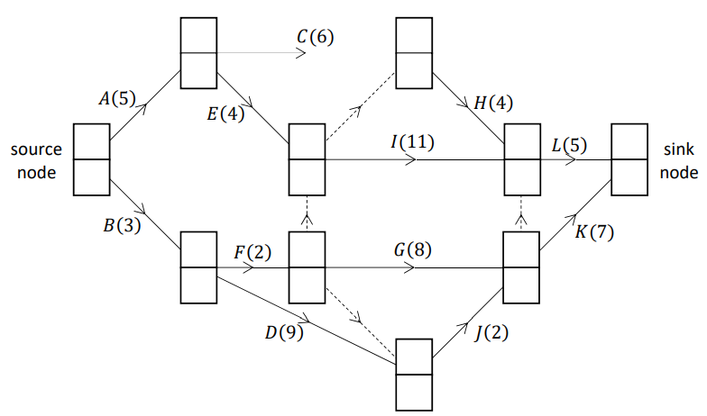

1. Write down the critical path for the network.
2. Write down the minimum time, in days, needed to complete this project.
3. Select any one non‐critical activity on the network and calculate its float, in days.
4. The project is due to begin on the morning of July 1st. The key worker needed to carry out activity 𝐺 will be away on holidays when the project begins.   
   What is the latest date on which this worker could return to work without necessarily causing the project to be delayed? Justify your answer.

**2023 Deferred HL Question 9**

The diagram below shows the scheduling network for a project to construct a stage for a music performance. The network provides some information about the relationships between the thirteen activities that have to be completed in the project.

The edges of the network represent these activities and are labelled with the letters 𝐴 to 𝑀.

The letters used to label the edges should not be taken as representing the order in which the activities happen.

The nodes of the network represent events or points in time during the project. The source node is the time when the project begins and the sink node is the time when the project ends.

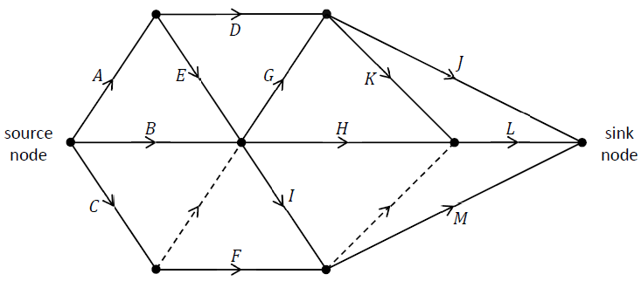

1. Explain the significance of the edges represented by dotted lines.
2. Complete the table below by listing, for each activity, the other activities on which it depends directly. That is, for each activity 𝑋 ∈ {𝐴, 𝐵, 𝐶, … , 𝑀}, write the smallest possible list of other activities which need to be completed before activity 𝑋 can begin.

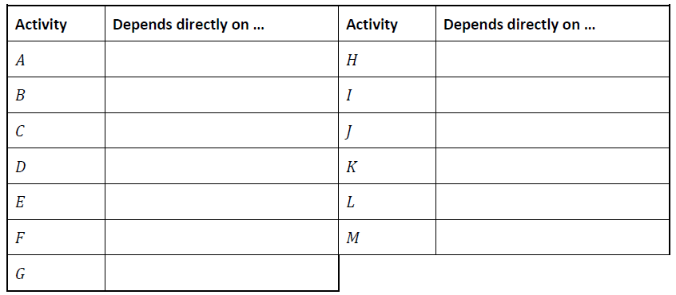

1. The time, in hours, to complete each of the activities is represented by the number in brackets.   
   Calculate the early time and the late time for each event.

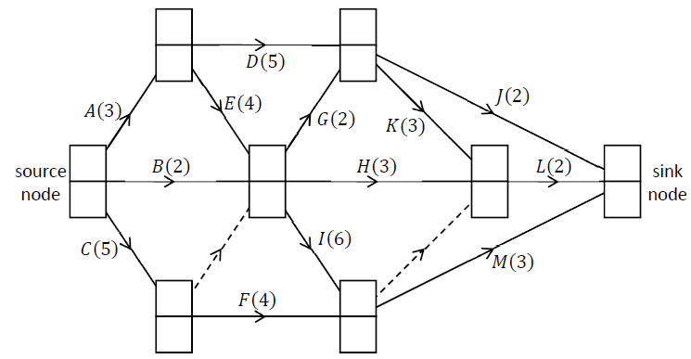Complete the diagram below by writing the early time (upper box) and late time (lower box) at the node representing each event.

1. Write down the critical path(s) for the network.
2. Calculate the minimum time needed to complete the project.
3. If activity 𝐷 takes 7 hours instead of 5 hours, what effect will this have on the critical path(s) and the time it takes to complete the project? Explain your answer.
4. If activity 𝐽 takes 7 hours instead of 2 hours, what effect will this have on the critical path(s) and the time taken to complete the project? Explain your answer.

## Precedence tables PLUS Early & Late times & Critical Paths PLUS Gantt charts: Higher Level

**2023 HL Question 9**

The manager of a regional hospital decides to arrange for the refurbishment of one of the hospital wards. The diagram below shows the scheduling network for the project.

The edges of the network represent the activities that have to be completed as part of the project and are labelled with the letters 𝐴 to 𝐿.

The duration, in days, of each activity is represented by the number in brackets. The unlabelled edges (shown with dashed lines) do not represent real activities but they help explain the order in which the activities must happen.

The letters used to label the edges should **not** be taken as representing the order in which the activities happen.

The nodes of the network represent events or points in time during the project.

The source node is the time when the project begins and the sink node is the time when the project ends.

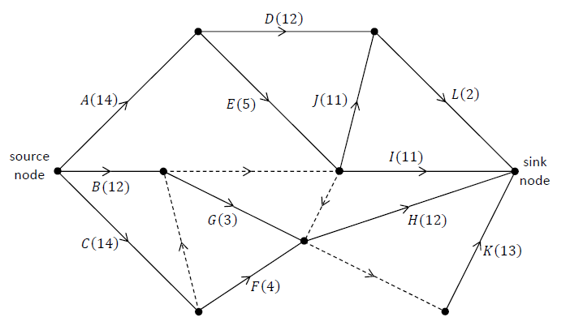

1. Complete the table by listing, for each activity, the other activities on which it depends directly. That is, for each activity 𝑋 ∈ $\left\{A, B, C, … , L\right\}$, write the smallest possible list of other activities which need to be completed before activity 𝑋 can begin.

|  |  |  |  |  |
| --- | --- | --- | --- | --- |
| **Activity** | **Depends directly on . . .** |  | **Activity** | **Depends directly on . . .** |
| ***A*** |  |  | ***G*** |  |
| ***B*** |  |  | ***H*** |  |
| ***C*** |  |  | ***I*** |  |
| ***D*** |  |  | ***J*** |  |
| ***E*** |  |  | ***K*** |  |
| ***F*** |  |  | ***L*** |  |

1. Calculate the early time and the late time for each event.

Complete the diagram below by writing the early time (upper box) and late time (lower box) at the node representing each event.

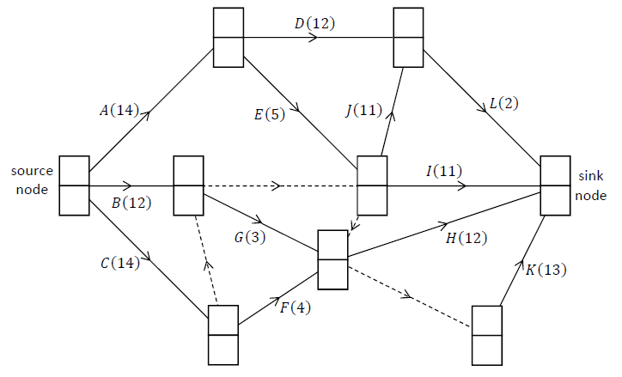

Write down the critical path(s) for the network.

A cascade chart (Gantt chart) is a type of bar chart which may be used to represent a project’s schedule. The duration of each activity is represented by the width of the horizontal bar for that activity, with time on the horizontal axis. The float time for an activity is represented by a rectangle drawn using dotted lines to the right of the bar for that activity. The top row of a cascade chart is used for a critical path.

Draw a cascade chart or similar bar chart to represent the schedule for this project.

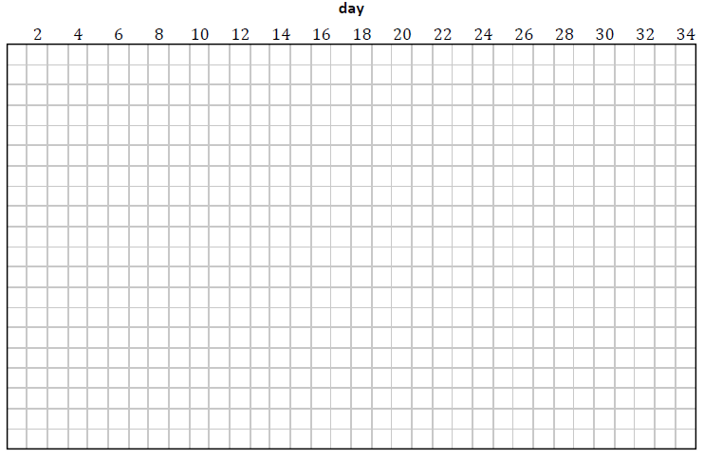

The hospital manager visits the project on day 18 to check the progress of the work, which is on schedule.

Write down the activities which may be happening on day 18.

## Bellman’s Principle of Optimality

**Sample paper OL Question 7 (c)**

A coach operator wishes to design a new four‐day coach route from city 𝐴 to city 𝐽.

The coach will depart from city 𝐴 on Monday morning and should arrive in city 𝐽 on Thursday evening. On Monday night the coach will stop in city 𝐵, 𝐶 or 𝐷. On Tuesday night the coach will stop in city 𝐸, 𝐹 or 𝐺. On Wednesday night the coach will stop in city 𝐻 or 𝐼.

Passengers may begin or end their journey at any city.

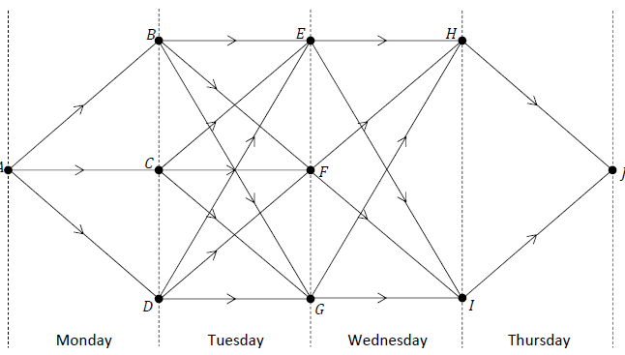The operator draws the network shown below to help him design this route.  
The table below gives the number of passengers who wish to travel between pairs of cities on each day.

|  |  |  |  |  |
| --- | --- | --- | --- | --- |
| **Journey** | **Number of passengers** |  | **Journey** | **Number of passengers** |
| 𝐴 to 𝐵 | 32 |  | 𝐷 to 𝐹 | 45 |
| 𝐴 to 𝐶 | 27 |  | 𝐷 to 𝐺 | 23 |
| 𝐴 to 𝐷 | 19 |  | 𝐸 to 𝐻 | 43 |
| 𝐵 to 𝐸 | 36 |  | 𝐸 to 𝐼 | 34 |
| 𝐵 to 𝐹 | 41 |  | 𝐹 to 𝐻 | 17 |
| 𝐵 to 𝐺 | 45 |  | 𝐹 to 𝐼 | 26 |
| 𝐶 to 𝐸 | 22 |  | 𝐺 to 𝐻 | 32 |
| 𝐶 to 𝐹 | 38 |  | 𝐺 to 𝐼 | 46 |
| 𝐶 to 𝐺 | 29 |  | 𝐻 to 𝐽 | 36 |
| 𝐷 to 𝐸 | 30 |  | 𝐼 to 𝐽 | 25 |

Use Bellman’s Principle of Optimality to calculate the path from city 𝐴 to city 𝐽 which maximises the number of passengers who use the coach.

Relevant supporting work must be shown.

**2023 Deferred Question 6 (b)**

A project manager is responsible for maintaining a portion of road. The maintenance work is carried out in four stages. For each stage, the manager has a number of options regarding how to complete the work and which sub‐contractors to use.

The options available to the manager may be modelled as a network. The options are represented by edges, where the weight of the edge represents the cost of that option in thousands of euros. Some of the weights are negative because of discounts offered by sub‐contractors. The manager wishes to choose the optimal policy for maintaining the road, i.e. the cheapest overall plan.

The nodes 𝑋 and 𝑌 represent the initial and final states of the decision problem. Each of the other nodes represents a possible state of the decision problem.

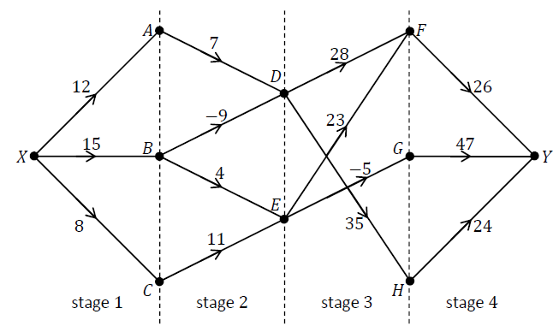

Calculate the plan which minimises the cost of maintaining the road. Relevant supporting work must be shown.